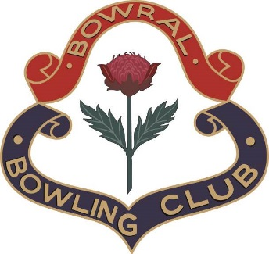

**BOWRAL BOWLING CLUB LTD BOARD ELECTION**

**NOMINATION AND ACCEPTANCE FORM**

|  |  |
| --- | --- |
| **THIS FORM MUST BE LODGED WITH THE BOARD ELECTION RETURNING OFFICER** | |
| *At (Address)* | 40 Shepherd Street, Bowral |
| *By (Date and Time)* | 18th August 2024 @ 5pm (into the supplied nomination box) |
| **I** (*Full Name)* |  |
| **OF** |  |
| *Full Residential Address* |  |
| *Contact Phone Number(s)* |  |
| *Membership Badge Number* |  |
| **HEREBY NOMINATE** |  |
| *Full Name* |  |
| *Full Residential Address* |  |
| *Contact Phone Number(s)* |  |
| *Contact Phone Number(s)* |  |
| *Membership Badge Number* |  |
| **FOR THE POSITION(S) OF** |  |
| *Signature of Proposer* | Date: |
| **SECONDER** |  |
| *Full Name* |  |
| *Full Residential Address* |  |
| *Contact Phone Number(s)* |  |
| *Membership Badge Number* |  |
| *Signature of Seconder* | Date: |
| **I** *(Full Name)* |  |
| **OF** |  |
| *Full Residential Address* |  |
| *Contact Phone Number(s)* |  |
| *Membership Badge Number* |  |
| **HEREBY ACCEPT THE NOMINATION FOR THE POSITION(S) OF** |  |
| *Signature of Candidate* | *Date:* |